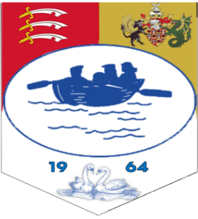

Adopted May 2014
Reviewed – Annually

GENERAL ARRANGEMENTS - ACCIDENTS AND EMERGENCIES

GENERAL RESPONSIBILITY

In an emergency action must be based on commonsense, care and acquaintance with instructions. It is the responsibility of all staff to familiarise themselves with these instructions which are displayed in the Parish Office. these instructions will be regularly reviewed.

FIRE
- ﻿﻿Raise the alarm.
- ﻿﻿Call the FIRE SERVICE ( DIAL 999 )
- ﻿﻿Evacuate the building by the approved route. Close all doors and windows behind you if time allows. If the fire is minor attempt to extinguish with the nearest appliance.
- ﻿﻿DO NOT TAKE RISKS

FIRST AID
- ﻿﻿First aid boxes are maintained both in the office at 98, Ferry Road and in the vehicle used by the General Maintenance Officer.
- ﻿It is the responsibility of the Clerk to the Council to ensure that the first aid boxes are replenished.

INJURY
- In the event of a major injury the Ambulance Service should be called immediately, and the injured person kept warm. They should not be moved nor given any form of food or liquid.

ELECTRIC SHOCK

- Don't touch an injured person who is still in contact with an electrical current.
- Call 999 or your local emergency number if the source of the burn is a high-voltage wire or lightning.
- Don't move a person with an electrical injury unless there is immediate danger.
- ﻿﻿Inform the Electricity Company.

GAS - SUSPECTED LEAK

- ﻿﻿Turn off the gas supply and open all windows.
- ﻿﻿Inform the Gas Company.
- ﻿﻿Do not use a flame to test for leaks.
- ﻿If you are unable to stop the gas leak evacuate the building.

TRAFFIC ACCIDENT

- ﻿﻿A FIRST AID box is maintained in the vehicle used by the General Maintenance Officer and must be in a prominent position.
- ﻿In the event of an accident involving injury the Ambulance and Police Services should be informed and a full report made to the Clerk of the Council as soon as possible. The driver should endeavour to obtain witnesses If possible.

